2023 ASIAN YOUTH CUP
SPEED

SINGAPORE
8 JULY 2023

ORGANISED BY:

- ORGANIZATION

Organizer: Singapore Sport Climbing and Mountaineering Federation (SSCMF)
Address: 3 Stadium Drive, #01-33 Singapore 397630
Email: admin@smf-climbing.org
Website: https://smf-climbing.org

President SSCMF: Mr. Anthony SEAH
Secretary General: Mr. Rasip Isnin
Sport Manager: Ms. Hayati Suaidi
Sport Executive: Ms. Diyan Haziqah

- IFSC OFFICIALS

Technical Delegate: Francis LO (HKG) fsclo@yahoo.com.hk +852 91948250
Jury President: Raymond CHAN (HKG) raymondchan99@gmail.com +852 90339262
Judge: Noor Zamir MOHAMED YUNOS (SGP)

- REGISTRATION

Licenses: Only competitors and team officials with a valid IFSC international license are allowed to register for the competition.
IFSC Online Registration System: http://ifsc.results.info/users/login
Pre-registration: In order to support the efficient organization of the competitions, it is very important that National Federations register participants to the competitions as early as possible.
Deadline: The deadline for registration is 15 days before the first day of competition (the “Registration Date”) on 22 June 2023 at 11:59 PM UTC+0.
Quota: Member Federation may register eligible three (3) competitors (for the host nation, six (6) competitors) for each Category and Discipline within the competition.
Age Groups:
Junior (otherwise referred to as Under 20 or “U20”) means the age group comprising competitors who are or will be 18 or 19 years of age in this year.
Youth A (otherwise referred to as Under 18 or “U18”) means the age group comprising competitors who are or will be 16 or 17 years of age in this year.
Youth B (otherwise referred to as Under 16 or “U16”) means the age group comprising competitors who are or will be 14 or 15 years of age in this year.

- FEES

All fees are the sole responsibility of the Member Federation and are as follows:
Athlete Registration Fee (per discipline) – US$30;
Team Official Registration Fee (per official) – US$20;
Appeal Fee – US$100

Registration fee will be collected during confirmation of attendance in cash in US Dollars only.
The appeal fee shall be paid directly to the Appeal Jury when a written appeal is filed in accordance with article 9.24 of the IFSC Rules 2023.

- PRE-EVENT REGULATIONS

All athletes and team officials are recommended to have insurance coverage, covering hospitalization and all other medical coverage if required due to COVID-19 and possible repatriation back to their home country. The IFSC will not be responsible for any of these costs.

- CONFIRMATION OF ATTENDANCE & TECHNICAL MEETING

Venue: TBC
For the registration on Friday, it is necessary for all team managers to show the passports or ID-cards of their competitors (or copy).

Physical confirmation of registration is mandatory. Team Managers must present passports of the registered competitors during the confirmation of attendance. Failure to do so shall make the relevant competitor ineligible to compete.
In case of late arrival please contact the Technical Delegate by Whatsapp at +852 9194 8250.

- PROVISIONAL PROGRAMME (LOCAL TIME)

Friday 7th July
 | 15:00 – 17:00 | Confirmation of attendance (Venue TBC)
 | 18:00 | Technical Meeting (Venue TBC)
Saturday 8th July
 | 08:00 | Warmup Wall Open
 | 09:00 | Speed Practice
 | 13:00 | Speed Qualification – YB Women
 | 13:30 | Speed Qualification – YB Men
 | 14:15 | Speed Qualification – YA Women
 | 14:45 | Speed Qualification – YA Men
 | 15:30 | Speed Qualification – JR Women
 | 16:00 | Speed Qualification – JR Men
 | 16:45 | Speed Final – YA Men & Women
 | 17:25 | Speed Final – YB Men & Women
 | 18:05 | Speed Final – JR Men & Women
 | 19:00 | Award Presentation

- ACCOMMODATION

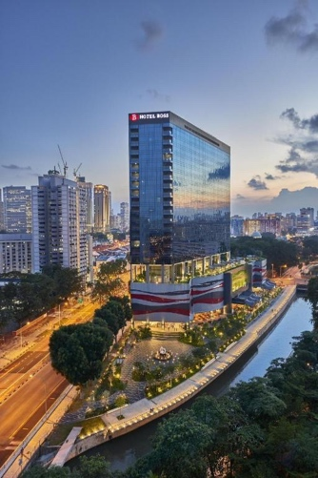

Contact Details:
Hotel Boss
Further details on reservations – Please contact admin@smf-climbing.org
Transport to venue will be provided for athletes and officials from official hotel.

- COMPETITION VENUE

NATIONAL YOUTH SPORTS INSTITUTE (NYSI) STADIUM LANE

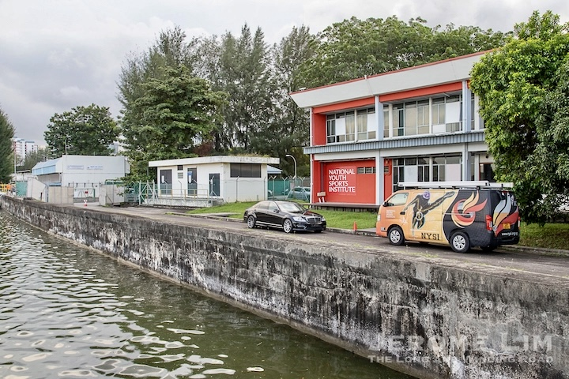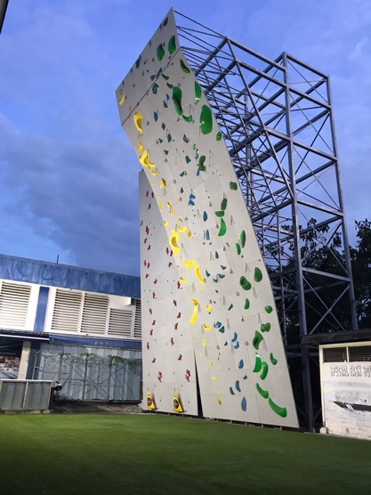
To get to NYSI
https://www.nysi.org.sg/YCC2020/location

- VISA AND TRAVEL

VISA:
Please check if you need visa at website of the Ministry of Foreign Affairs of Singapore:
https://www.mfa.gov.sg/Services/Visitors/Visa-Information
If you need visa, please contact SSCMF: admin@smf-climbing.org

First  Name | Last  Name | Birth  Date | Place of  Birth | Nationality | Passport  Number | Expiration  Date | Address | Phone Number / e-mail | Occupation | Place of Visa Application
Please don’t forget to attach a scanned passport copy.

HOW TO GET TO SINGAPORE
By Plane
Singapore Changi International Airport
From Changi Airport to Official Accomodation
There is a wide range of options for traveling buses, trains or taxi.

- HEALTHCARE SYSTEM INFORMATION

COVID-19 Outbreak Response Coordinator Doctor: TBD
Emergency local doctor during the event: TBD

RESPONSE PROTOCOL IN CASE OF POSITIVE COVID TEST
In any case (symptoms or positive test) the team manager has to inform immediately the COVID-19 Outbreak Response Coordinator Doctor and the Technical Delegate.
The person suspected must be immediately placed in a separate room and kept away from the event.

